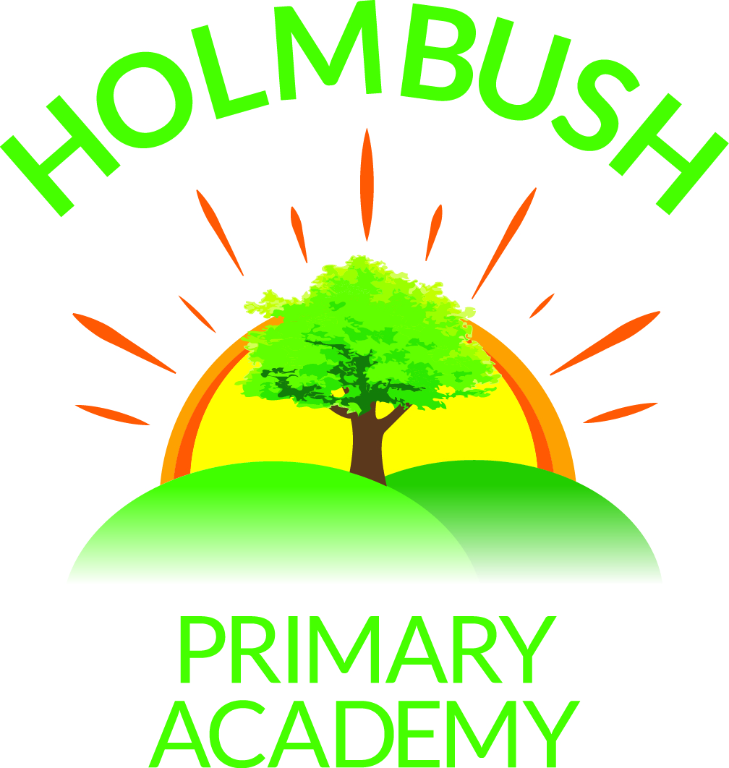

HOLMBUSH PRIMARY ACADEMY
Hawkins Crescent
Shoreham-by-Sea
West Sussex
BN43 6TN
Telephone 01273-592471
Tel/Fax 01273-592660

Email office@holmbushprimaryacademy.org.uk
www.holmbushprimaryacademy.org.uk

Head of Learning: Ms Rebecca Jackson BEd Hons, MA Ed, NPQH

June 2015

Dear Parents/Carers

Year 1 & 2 – Visit to Woods Mill

As part of this term’s topic, “Creepers and Crawlers”, a visit to Woods Mill has been arranged for the Year 1 and 2 classes on Monday 29th June.

The children will be travelling on coaches which are fully fitted with seatbelts, leaving school at 9.15am and returning at 3.00pm. If your child suffers from travel sickness please ensure that they have taken appropriate medication before school. Normal school hours apply. During the visit children will be divided into small groups, each supervised by an adult. The class teacher will remain in overall charge of all groups.

Children will need to wear school uniform for easy identification and footwear suitable for the weather conditions on the day of the visit. In view of the changeable weather conditions at this time of the year, please ensure that your child brings a coat, a sun hat and has had sun cream applied before coming to school.

Children will be provided with a packed lunch but if you would prefer to provide one for them please let the office know by Thursday 11th June.

In order to meet the cost of the visit we are requesting contributions of £14.00 which will include insurance cover for each child. Please make payment online by Wednesday 24th June.

Yours faithfully

Mrs R Jackson
Headteacher

